Certificate Generation and Validation Using OpenSSL
Introduction
Digital certificates play a critical role in securing modern communications by enabling authentication, encryption, and trust between systems. Certificates are a fundamental component of Public Key Infrastructure (PKI), which provides a framework for managing cryptographic keys and digital identities.
The objective of this project was to generate, inspect, and validate a self-signed digital certificate using OpenSSL. The exercise provided practical experience with RSA key generation, Certificate Signing Requests (CSRs), certificate issuance, and certificate verification procedures commonly used in enterprise and cybersecurity environments.
Understanding PKI and Digital Certificates
Public Key Infrastructure (PKI) is a security framework that uses asymmetric cryptography to establish trust between users, systems, and services. PKI relies on a pair of cryptographic keys:
- A private key that must remain confidential.
- A public key that can be shared openly.
Digital certificates bind a public key to an identity and allow systems to verify authenticity and establish secure communications.
In real-world environments, certificates are typically issued by trusted Certificate Authorities (CAs). For this project, a self-signed certificate was created for demonstration and learning purposes.
Private Key Generation
The first step involved generating a 2048-bit RSA private key using OpenSSL.
Command Used:
openssl genrsa -out itskillcentre.key 2048
This command generated a secure private key that was later used to create the Certificate Signing Request and sign the digital certificate.
Generated File:
itskillcentre.key
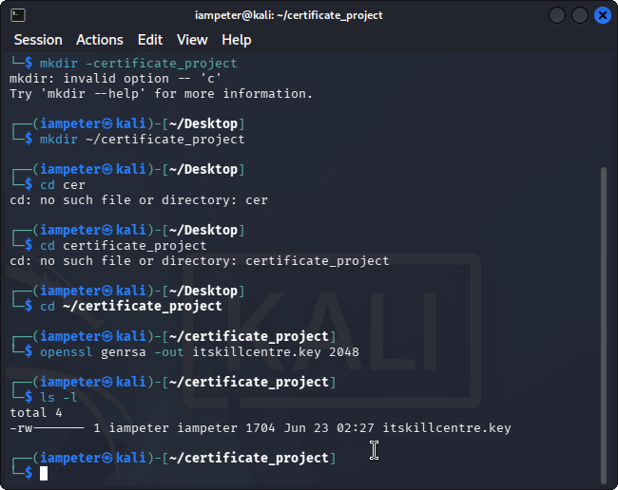
Certificate Signing Request (CSR) Creation
A Certificate Signing Request was generated using the previously created private key.
Command Used:
openssl req -new -key itskillcentre.key -out itskillcentre.csr
The CSR included organizational information such as:
- Country: NG
- State: Lagos
- Organization: ITSKIILCENTER Ltd
- Organizational Unit: Cybersecurity Department
- Common Name: itskiilcenter.local
- Email Address: iampeterb001@gmail.com
Generated File:
itskillcentre.csr
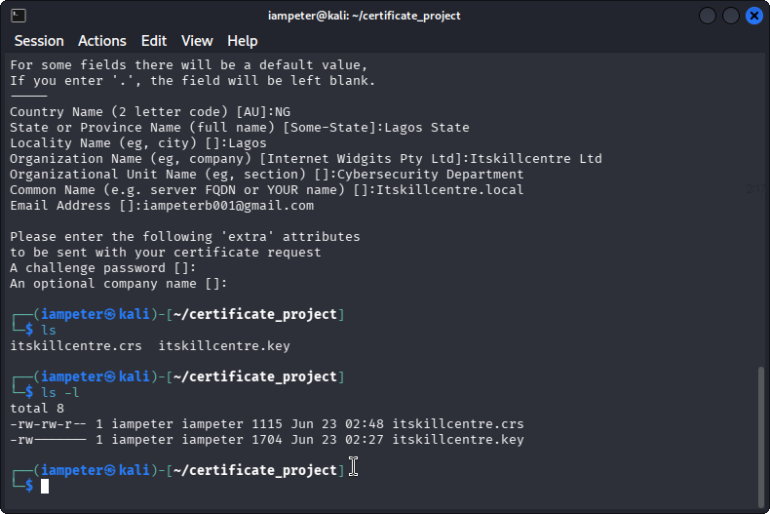
Self-Signed Certificate Generation
A self-signed certificate was created using the CSR and private key.
Command Used:
openssl x509 -req -days 365 -in itskillcentre.csr -signkey itskillcentre.key -out itskillcentre.crt
The certificate was configured with a validity period of 365 days.
Generated File:
itskillcentre.crt
Certificate Inspection
The generated certificate was inspected to verify its contents.
Command Used:
openssl x509 -in itskillcentre.crt -text -noout
The inspection confirmed:
- Subject information
- Issuer information
- Public key details
- Signature algorithm
- Validity period
- Certificate attributes
Since the certificate was self-signed, the Subject and Issuer fields were identical.
Certificate Validation
The certificate was validated using OpenSSL.
Command Used:
openssl verify -CAfile itskillcentre.crt itskillcentre.crt
Validation Result:
itskillcentre.crt: OK
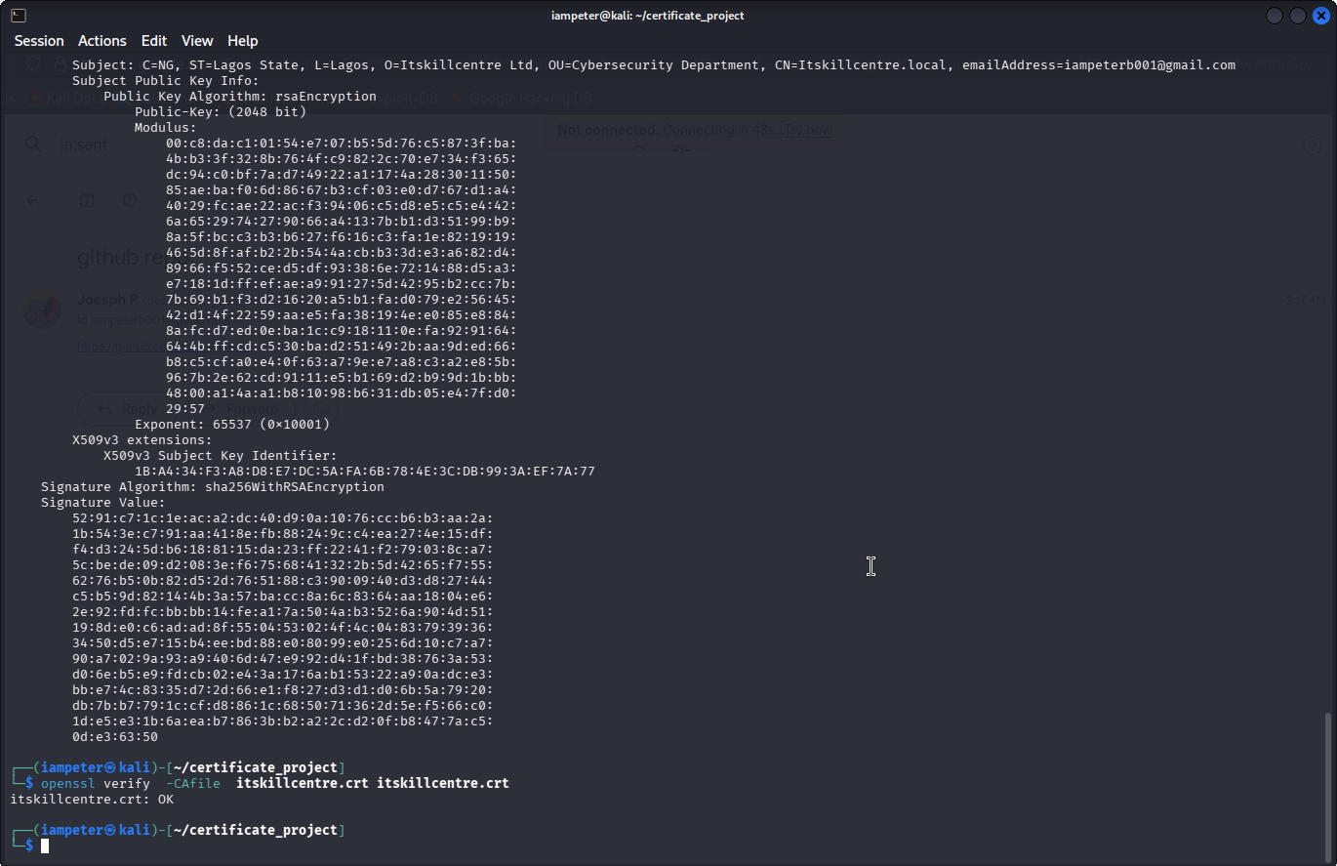
This confirmed that the certificate was correctly signed and could be trusted when used as its own certificate authority.Security Considerations
Several important cybersecurity concepts were demonstrated during this project:
- Private keys must be protected from unauthorized access.
- Certificates establish trust between systems and users.
- Self-signed certificates are suitable for testing environments but are not generally recommended for public-facing production services.
- Certificate expiration dates must be monitored and renewed before they expire.
- PKI provides the foundation for HTTPS, VPNs, secure email, and many enterprise security solutions.
Lessons Learned
This project provided practical experience with Public Key Infrastructure and digital certificate management. Through the use of OpenSSL, a private key, CSR, and self-signed certificate were successfully created and validated.
The exercise improved understanding of certificate lifecycles, cryptographic trust relationships, and the importance of proper key management in cybersecurity environments.
Conclusion
The project successfully demonstrated the complete process of certificate generation and validation using OpenSSL. A secure RSA private key was created, a CSR was generated, a self-signed certificate was issued, and the certificate was inspected and validated successfully.
The skills gained through this exercise provide a strong foundation for understanding PKI, secure communications, and certificate management in enterprise and cybersecurity environments.

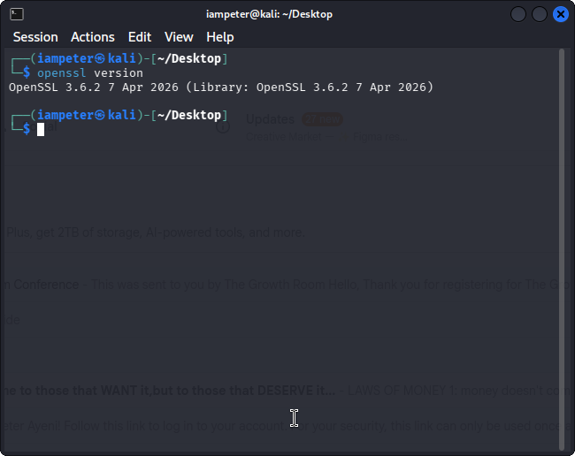
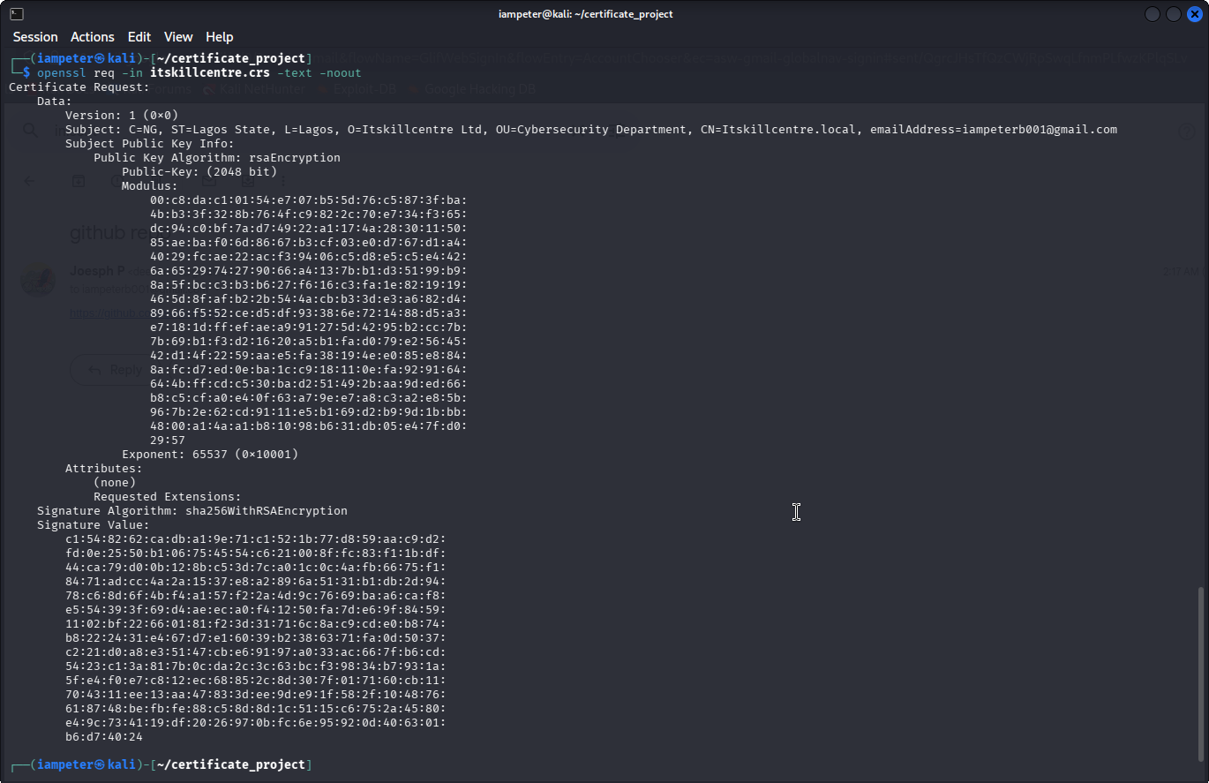

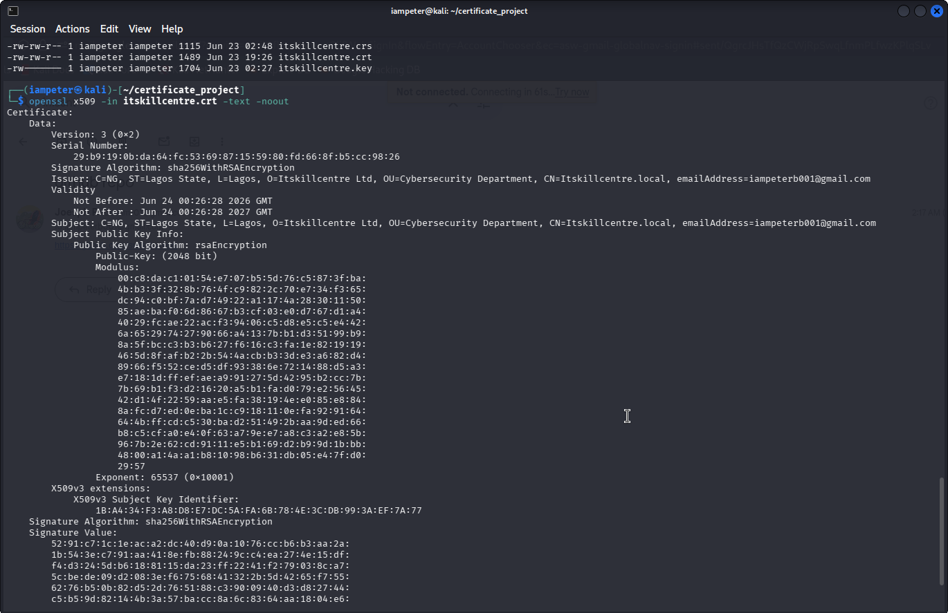

Practical Certificate Deployment and Browser Testing
To further validate the generated certificate, it was deployed to a local HTTPS server using the OpenSSL s_server utility. This simulated how a web server presents its digital certificate to a web browser during a secure HTTPS connection.
The following command was used:
openssl s_server -key itskillcentre.key -cert itskillcentre.crt -accept 8443 -www
After starting the server, a web browser was opened and navigated to:
https://localhost:8443
The browser successfully established communication with the local server but displayed a security warning because the certificate was self-signed and not issued by a trusted Certificate Authority (CA).
This behaviour is expected and demonstrates an important security concept: a certificate can be cryptographically valid while still being untrusted by browsers if it is not signed by a recognized CA.
The browser also allowed inspection of the certificate details, including the subject, issuer, validity period, and encryption algorithm, confirming that the certificate had been generated correctly.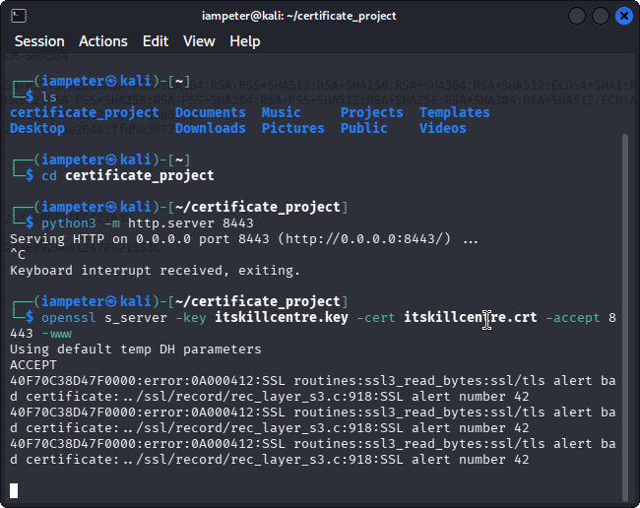

Trust, Verification, and Protection Against Man-in-the-Middle (MITM) Attacks
One of the primary purposes of digital certificates is to establish trust between a client and a server. When a user visits an HTTPS website, the server presents its digital certificate to the browser. The browser verifies several properties before establishing a secure connection:
- The certificate has not expired.
- The certificate has not been altered.
- The domain name matches the certificate.
- The certificate was issued by a trusted Certificate Authority (CA).
If any of these checks fail, the browser warns the user that the connection may not be secure.
This verification process is one of the most effective defenses against Man-in-the-Middle (MITM) attacks. In a MITM attack, an attacker attempts to intercept communications by pretending to be a legitimate server. If the attacker presents a fake or self-signed certificate that is not trusted by the browser, the browser detects the issue and warns the user before any sensitive information is exchanged.
During this project, the browser displayed a warning because the certificate was self-signed rather than issued by a trusted CA. This behaviour confirmed that browser trust mechanisms were functioning correctly and demonstrated the difference between a valid certificate and a trusted certificate.


